**Nested Conditional Statements**

Nested Conditions

The conditional block inside another if/else conditional block is called as *nested conditional block*. In the below example, *Block 2* is nested conditional block and *condition B* is called nested conditional statement.

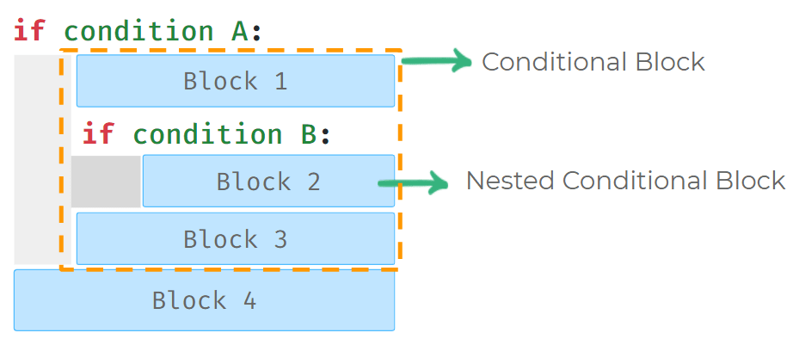

**Code**



1

2

3

4

5

6

matches_won = int(input())

goals = int(input())

if matches_won > 8:

if goals > 20:

print("Hurray")

print("Winner")

PYTHON

**Input**



10

22

**Output**



Hurray

Winner

**Input**



10

18

**Output**



Winner

Nested Condition in Else Block

We can also write nested conditions in Else Statement.

In the below example *Block 2* is a nested conditional block.

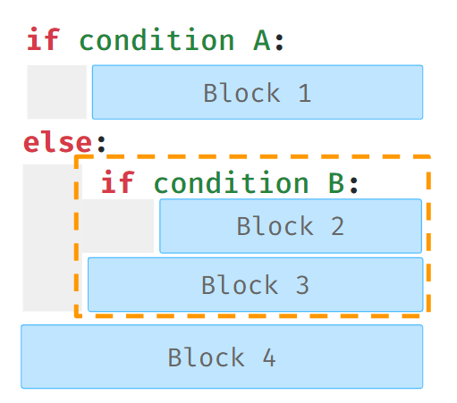

**Code**



1

2

3

4

5

6

7

8

9

10

11

a = 2

b = 3

c = 1

is_a_greatest = (a > b) and (a > c)

if is_a_greatest:

print(a)

else:

is_b_greatest = (b > c)

if is_b_greatest:

print(b)

else:

PYTHON

**Output**



3

Elif Statement

Use the elif statement to have multiple conditional statements between if and else.

The elif statement is optional.

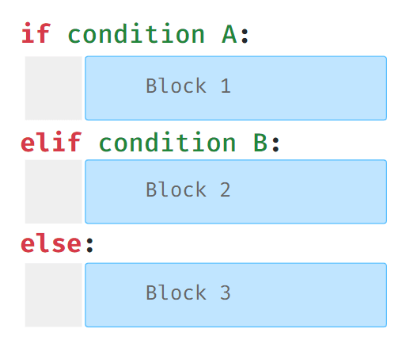

Multiple Elif Statements

We can add any number of

elif

statements after

if

conditional block.

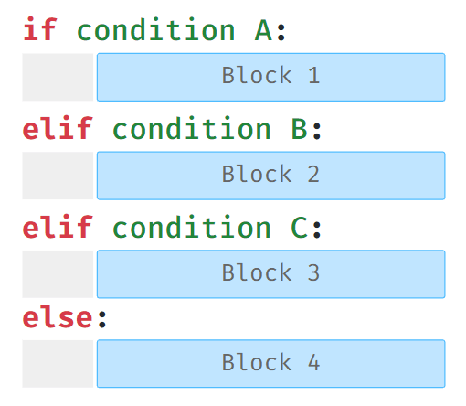

Execution of Elif Statement

Python will execute the elif block whose expression evaluates to true.  
If multiple

elif

conditions are true, then only the first elif block which is True will be executed.



Optional Else Statement

Else statement is not compulsory after

if - elif

statements.

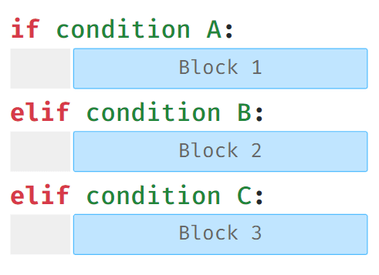

**Code**



1

2

3

4

5

6

7

8

9

number = 5

is_divisible_by_10 = (number % 10 == 0)

is_divisible_by_5 = (number % 5 == 0)

if is_divisible_by_10:

print("Divisible by 10")

elif is_divisible_by_5:

print("Divisible by 5")

else:

print("Not Divisible by 10 or 5")

PYTHON

**Output**



Divisible by 5

Possible Mistake

Cannot write an elif statement after

else

statement.

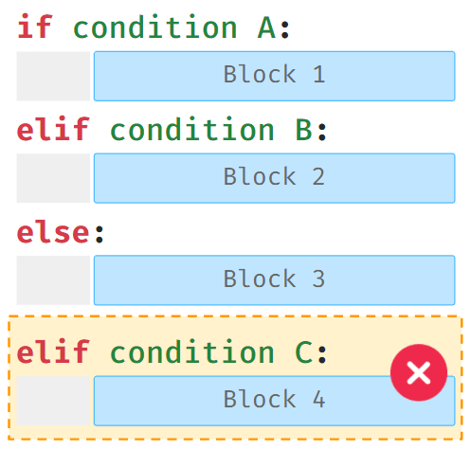

Notes